September
2014  Production  Schedule | 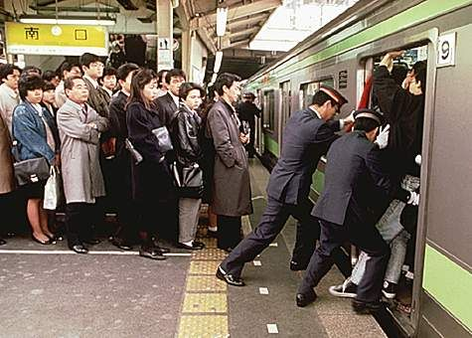

Sunday | Monday | Tuesday | Wednesday | Thursday | Friday | Saturday
 | 1 | 2 | 3 | 4 | 5 | 6
7 | 8 | 9 | 10 | 11 | 12 | 13
14 | 15 | 16 | 17 | 18 | 19 | 20
21 | 22 | 23 | 24 | 25 | 26 | 27
28 | 29 | 30

Notes:

PROPS LIST

- __________________________
- __________________________
- __________________________
- __________________________
- __________________________
- __________________________
- __________________________
- __________________________
- __________________________
- __________________________
- __________________________
- __________________________
- __________________________
- __________________________
- __________________________

NAME OF THE SCENE (IN ORDER OF APPEARANCE) |PROPS REQUIRED |WHO WILL PUT PROPS INTO POSITION?

- SCENE ______________ PROPS REQUIRED ________________________________WHO ______________________
- SCENE ______________ PROPS REQUIRED ________________________________WHO ______________________
- SCENE ______________ PROPS REQUIRED ________________________________WHO ______________________
- SCENE ______________ PROPS REQUIRED ________________________________WHO ______________________
- SCENE ______________ PROPS REQUIRED ________________________________WHO ______________________
- SCENE ______________ PROPS REQUIRED ________________________________WHO ______________________
- SCENE ______________ PROPS REQUIRED ________________________________WHO ______________________
- SCENE ______________ PROPS REQUIRED ________________________________WHO ______________________
- SCENE ______________ PROPS REQUIRED ________________________________WHO ______________________
- SCENE ______________ PROPS REQUIRED ________________________________WHO ______________________
- SCENE ______________ PROPS REQUIRED ________________________________WHO ______________________
- SCENE ______________ PROPS REQUIRED ________________________________WHO ______________________
- SCENE ______________ PROPS REQUIRED ________________________________WHO ______________________
- SCENE ______________ PROPS REQUIRED ________________________________WHO ______________________
- SCENE ______________ PROPS REQUIRED ________________________________WHO ______________________
- SCENE ______________ PROPS REQUIRED ________________________________WHO ______________________
- SCENE ______________ PROPS REQUIRED ________________________________WHO ______________________
- SCENE ______________ PROPS REQUIRED ________________________________WHO ______________________
- SCENE ______________ PROPS REQUIRED ________________________________WHO ______________________
- SCENE ______________ PROPS REQUIRED ________________________________WHO ______________________
- SCENE ______________ PROPS REQUIRED ________________________________WHO ______________________
- SCENE ______________ PROPS REQUIRED ________________________________WHO ______________________
- SCENE ______________ PROPS REQUIRED ________________________________WHO ______________________
- SCENE ______________ PROPS REQUIRED ________________________________WHO ______________________
- SCENE ______________ PROPS REQUIRED ________________________________WHO ______________________

