Making chlorophyll rubbings.
You will need leaves and a metal spoon.
Place leaves between a folded sheet of paper and then rubbed really hard with the spoon.

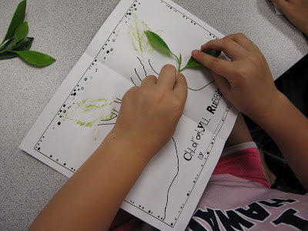

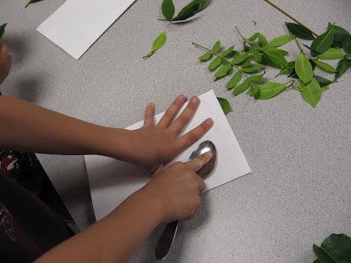

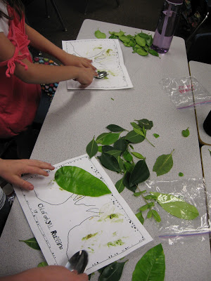

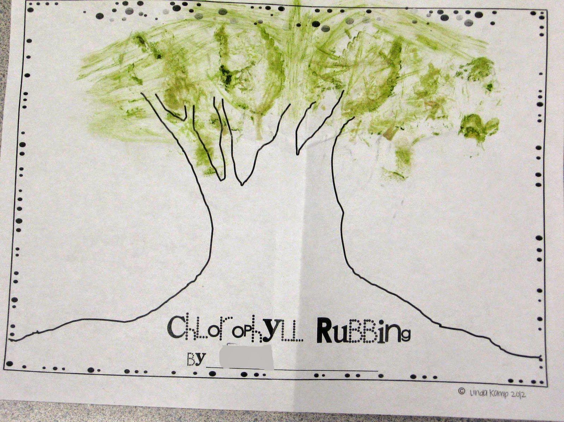

Some leaves work better than others. Thick, glossy leaves with a slick feel don't work as well.

