Year 11 / 12 DRAMA

How to review Live Theatre

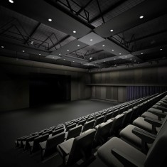
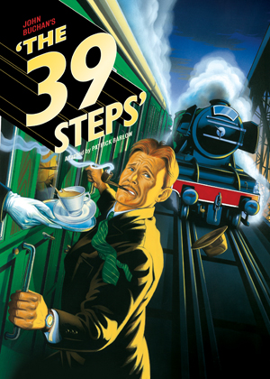
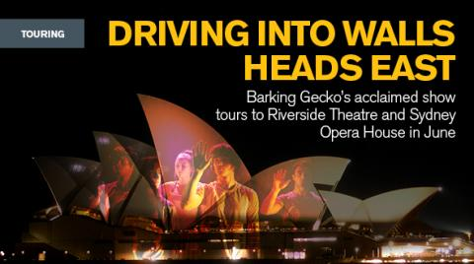

Assessment Criteria

As part of Year 11&12 Drama you are expected to complete an evaluation of a live Theatre Performance.
This piece of work accounts for 20% of the entire Drama mark.
This booklet should help you to prepare for the performance review, make notes and create your final written assessment. Be sure to read all the material and fill in the correct information.
Here are some examples from a good piece of work. Highlight the vocabulary that you think is effective.

“This version of “One Man, Two Guvnors” by Richard Bean, was directed by Nicholas Hytner and performed in the Adelphi Theatre on the 5th of January. It is a modern play set in Brighton, during the 1960s. The main actors included James Corden (British TV star) as Francis Henshaw, Oliver Chris as Stanley Stubbers, and Jemima Rooper as Rachel Crabbe. The play is based on Carlo Goldini’s “A Servant of Two Masters” (written in 1743), which is a classic example of the style: Commedia Dell Arte, which includes features such as physical comedy (slapstick, falling over) and audience participation. Knowledge of this genre, as well as the actors, led to the expectation, before seeing the play, that it would be entertaining, of a high standard and of a farcical nature, meaning fast-paced and extremely funny.”
Clear Introduction
“Each character in the performance had different ways of using voice, movement and gesture. For example, each had their own accent, differentiating them from each other, such as: Francis had a cockney accent; Stanley had a posh and upper-class one; and Dolly had a northern accent. Also, most characters used over-the-top, exaggerated movements, which created comedy, as they were slightly abnormal and strange, such as: Alan, whose character wants to be an actor and steps forward in an exaggerated way, to confront “Roscoe” when they meet, and always uses a loud voice”
Good section on acting style with a clear example from the play

“a live 60s style band played to the audience, creating a friendly, inclusive atmosphere, giving the audience a break from the fast-moving, slightly confusing plot.”

“the elderly waiter, was very effective in creating comedy, especially slapstick style, as his movements and gestures were very slow and fragile, as well as his facial expression being slightly crooked.”

“The set used for the streets was very well-fitted for this farce, as it used, what looked like, cardboard cut-outs for the houses, making up the shape of the streets, going upstage in rows. This created a “puppet-theatre” style set, which was used effectively, in one scene, when James Corden and another actor pretending to double for Francis, chased someone through these streets, reappearing from a different row of streets each time.”
Good section on set, with an example from the performance

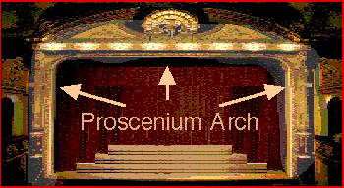
Where was the play performed? …………………………………..
Most West End Theatres have a large proscenium arch framing the action and three seating areas referred to as the stalls (closest to the stage) the circle (one level up) and the upper circle (the cheap seats)

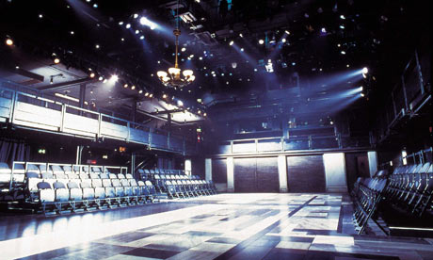

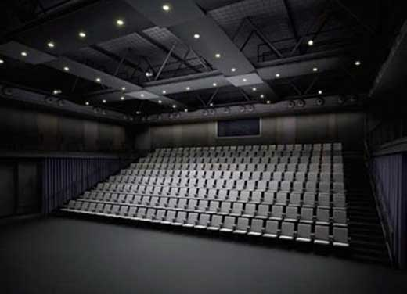
If you have audience on both sides it is called Traverse Staging
Studio Theatres are smaller, versatile spaces that can have audiences in different configurations.

What type of Theatre? Was it a large West End Theatre with a proscenium arch and large auditorium or a small studio theatre? How many seats does the Theatre have?
……………………………………………………………………………………….
Is it an original play or is it based on a film or book? ………………………

How long has it been performed and what cities? ……………………………………………
The mousetrap is London’s longest running play. It has been running since 1952 and has been performed over 24500 times

Who is the director? What else have they directed? ………………………………………………………………………………………
Who are the main actors? What else have they been in?
……………………………………………………………………………………………………………………………………………………………………………………
What are your expectations before seeing the performance? What genre do you expect the play to be?
…………………………………………………………………………………………………………………………………………………………………………………..

Read a Review of the play Highlight and make notes on the reviewers response

Set

Make a diagram of the set and label it. Most set designers draw sets from a bird’s eye view. It doesn’t have to be an amazing work of art.

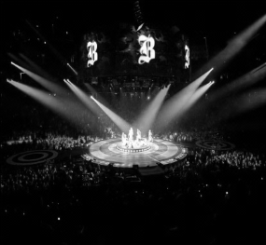
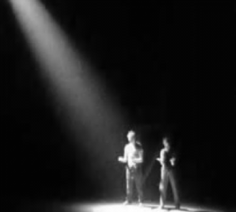

Design Elements

A plays design incorporates Lighting, Sound, Music, Set and Costume. There is usually a set designer, lighting designer, costume designer and sound designer who work in collaboration with the Director.

Lighting

Key Vocabulary
(Spotlight, Black out, General Flood, Back lit, Gobo, Fresnel, Strobe, Cross fade, Fade)
How is lighting used to designate location? …………………………………………………………………………………………
What colours are used? ………………………………………………………….
How is lighting used to create mood in the play? ……………………………………………………………………………………………………………………………………………………………………………………
Highlight a moment in the play where lighting is used effectively.
………………………………………………………………………………………………………………………………………………………………………………………………………………………………………………………………………………

Sound

Is music used in the play? What type of music is it? …………………….
Do actors create any of the music? Is there a band? ………………………………………………………………………….......................
Are there pre-recorded sound effects? What are they? …………………….. ……………………………………………………………………………………………………………………………………………………………………………………
How are sound effects and/or music used to create mood and atmosphere? …………………………………………………………………………………………………………………………………………………………………………………………………………………………………………………………………………………………………………………………………………………………………………

Set Design

Key Vocabulary
(Flats. Levels, Location, Symbolic, Realistic, Scene change, Texture, Materials, Props)
What is the set made out of? …………………………………………………….
What time period does the set represent? How? …………………………………………………………………………………………
What are the main colours used by the set designer? What do you think they represent? ……………………………………………………………………………………………………………………………………………………………………………………
Is the set naturalistic or symbolic? ………………………………………………
How is the set used in performance? Do actors move it? ……………………………………………………………………………………………………………………………………………………………………………………
Describe a moment when the set is used effectively.
………………………………………………………………………………………………………………………………………………………………………………………………………………………………………………………………………………
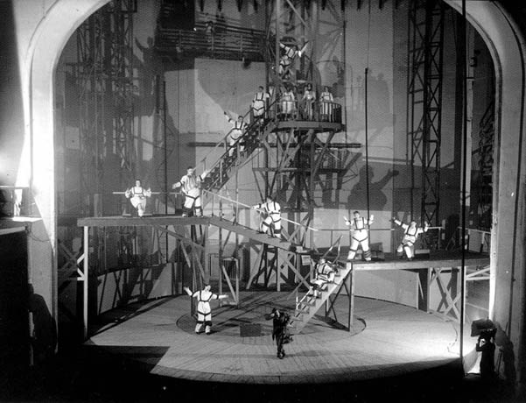
How are props used in the performance? Do they fit in with the overall design concept? ……………………………………………………………………………………………………………………………………………………………………………………
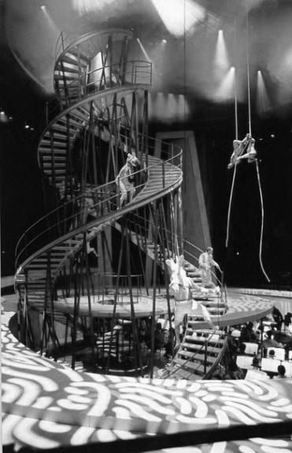

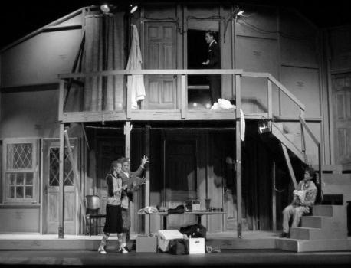

Vsevelod Meyerhold used set to reflect the industrialisation of 20th Century Russia, his actors worked as acrobats to exploit the sets many levels
Edward Gordon Craig is one of the most famous set designers.
Some sets are used naturalistically to give the audience a real feeling of time and place.

Costume
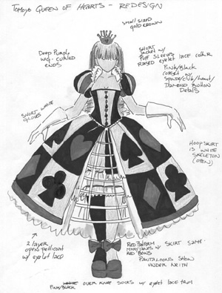
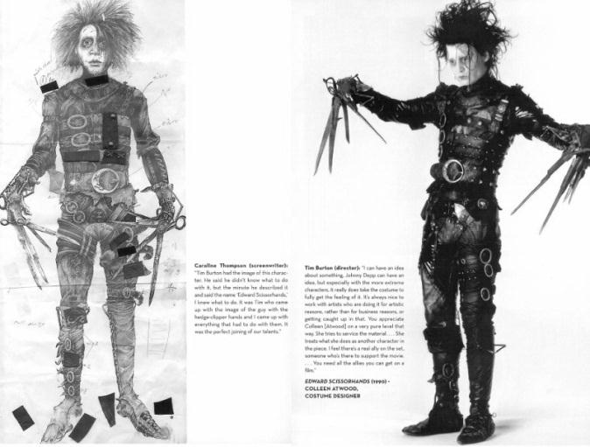

Costume Design Key Vocabulary
(Fabric, Colour, Time Period, Character, Texture, Symbolic, Representative)
What colours are used by the costume designer? What do they represent?
……………………………………………………………………………………………………………………………………………………………………………………
What clues does the costume tell you about the characters? What does the costume symbolise?
………………………………………………………………………………………………………………………………………………………………………………………………………………………………………………………………………………

Acting and Direction

What Genre would describe the performance? ………………………………
What moments of the performance tell you the play is in this genre? …………. ……………………………………………………………………………………………………………………………………………………………………………………
What is the style of the acting? Naturalism? Brechtian? ………………………………………………………………………………………….
What are the names of the main actors? What characters do they play? Does the play have a main character (Protagonist)? …………………………………………………………………………………………………………………………………………………………………………………… …………………………………………………………………………………………

Describe how one of the actors uses their voice and movement to portray their character. Try to give detailed, specific examples from the play.

Key Vocabulary
Voice Volume, Pitch, Articulation, Resonance, Timbre, Nasal, Rhythm
Movement Posture, Gait, Fluid, Rigid, Hunched, Tense, Relaxed, Gesture
…………………………………………………………………………………………………………………………………………………………………………………………………………………………………………………………………………………………………………………………………………………………………………………………………………………………………………………………………………………………………………………………………………………………………………………………………………………………………………………………
Describe a key moment of the performance. How does the acting, direction and staging contribute to the effectiveness of this moment?
Key Vocabulary Climax Anti-Climax Action Blocking Rhythm Timing
……………………………………………………………………………………………………………………………………………………………………………………………………………………………………………………………………………………………………………………………………………………………………………………………………………………………………………………………………
……………………………………………………………………………………………………………………………………………………………………………………………………………………………………………………………………................

How did the director vary the pace of the performance? ………………………... ……………………………………………………………………………………………………………………………………………………………………………………
Overall Response

What was your reaction to the play?
………………………………………………………………………………………………………………………………………………………………………………………………………………………………………………………………………………

Use this space to make any further notes or sketches that may help you

Evaluation of a live theatre performance.
1000 words maximum.
Overall response – What was your overall impression once the play had finished? What was the audience reaction both during and at the end of the play?
Acting and directing – Who were the key characters and what was their role in the action and plot? What did you notice about their use of voice, movement and gesture? How did the pace of the play change over time?

Describe a key moment of tension, climax or anti-climax and describe how this was created by the acting.
Design elements – what lighting (colours, spots, fades), sound and music (live, recorded, singing) was used? What kind of atmosphere did these choices create?

How did the set function in the play? Did the design of the set/props fit in with an overall theme – such as a specific time period? Costume choices –note the reasons for the colours and style of clothes. What effect did their clothes have on how we viewed the characters?

Performance area/staging – What is the type of stage used/ how are the audience positioned? How do the actors use the space and levels? Did the performance space used suit the production?

Describe the effect created between the actors and audience; intimate? Distant?
Intro – What is the title of the play and who is the playwright? What is the venue, date?

