Costume Designer Task – 10%
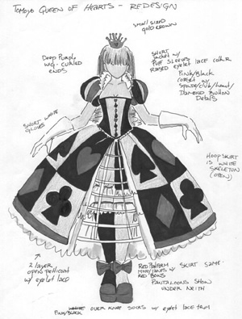
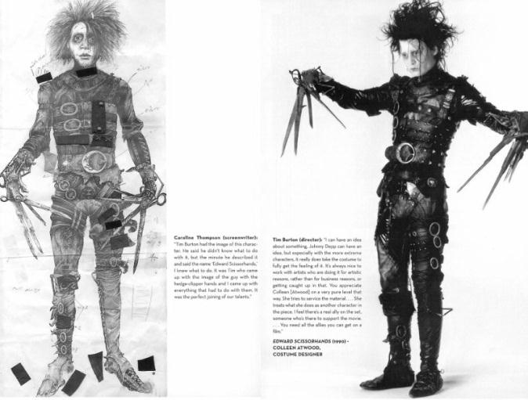

Costume Design - Key Vocabulary
(Fabric, Colour, Time Period, Character, Texture, Symbolic, Representative)
What colours do you use as a costume designer? What do they represent?
…………………………………………………………………………………………………………………………………………………………………………………………………..
Describe the costume of your main character in the Group Devised Performance.
………………………………………………………………………………………………………………………………………………………………………………………………………………………………………………………………………………………………………
Does your character change costume? Is the costume change done onstage or offstage?
…………………………………………………………………………………………………………………………………………………………………………………………………..
What clues does the costume tell the audience about your character? What does the costume symbolise?
……………………………………………………………………………………………………………………………………………………………………………………………………………………………………………………………………………………………………..

Sketch and Label your character’s costume(s) below: (You may use a larger piece of paper if you wish)

