http://animeworld.com/howtodraw/animagess/1-style.html

The first step in drawing "anime style" is just that--style. What kind of character are you drawing, and for what purpose?
For example, a magical schoolgirl will have a different facial structure and body proportions than, say, a villain.
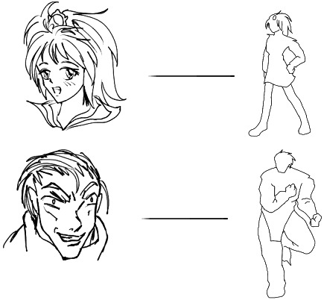
...Not to mention clothing, posture, and the fact that not all magical girls or villains will look like these examples. these are just basic guidelines to ensure that you don't end up with a magical schoolgirl with the body proportions of a DBZ character. (Unless, of course, that is what you want. There are no real rules when it comes to drawing anime.)
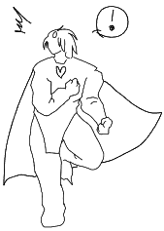
Style is completely a matter of preference, but it's a good idea to be aware of some of the main archetypes before going on to facial structure and body proportion.

Here are some examples
- Cute - Round cheekbones, large eyes, facial parts set close together.
- Evil - Drawn more 'realistically'. Sharp cheekbones, very small pupils.
- Shoujo - Sharp chins, huge expressive eyes, elegant nose bridges, slender body.
- Stupid - Round head and body, very simplistic features, tiny little eyes.
- Fighter (a la DBZ) - Simplistic features, exaggerated body proportions, small head.
But to draw all these characters, you must first know the basics of facial and body structures...
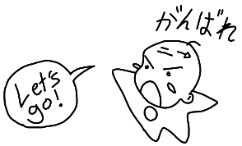

FACE STYLES AND DESIGN EXAMPLES
http://animeworld.com/howtodraw/animagess/2a-faces.html
We'll start with a bunch of examples of ways to draw the pieces that go together to make a face. These aren't the only ways to draw the parts, but they should give you an idea of where to start.

Here are some eyes:
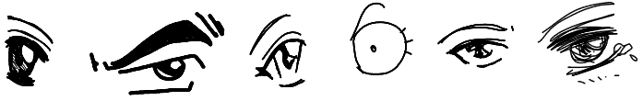

Here are some noses:
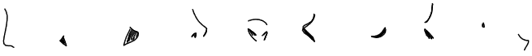

Here are some mouths:

Here are some ears:
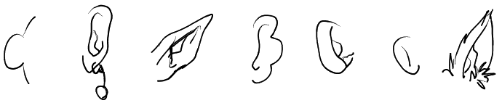

Here are some face shapes:
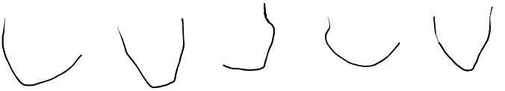

Here are some hairstyles:
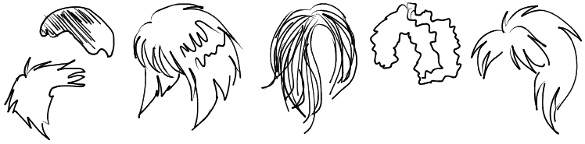
The next step is just learning how to put them all together.

FACE STRUCTURE

Here is step one:
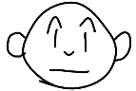
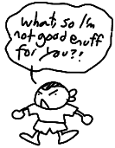Seriously, though, this is really all you need to create a decent anime character. Classic manga series have been built on less. But I'm sure you're all looking for something a bit more advanced, in which case we revert to something even simpler than we've got up there:
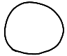
The rest is a little more complicated.
- Okay, so you take your circle...
- Now add a line down the direction the head is facing. 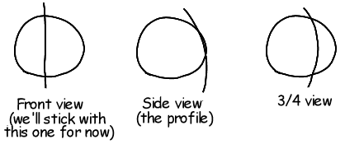
- Then add a horizontal line. Important: This is where the eyes are gonna go! 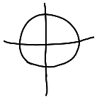
- Then add the lower jaw. This can be any shape or size you want, as long as its relatively symmetrical (else you end up with a butt-ugly character). 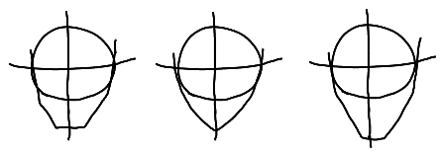
- Then you just add eyes, ears, nose, and mouth--not necessarily in that order, or number, for that matter! 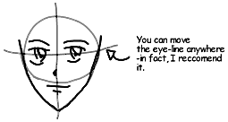
- Erase junk lines and touch-up. 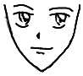
- Add stuff. 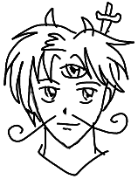
- Now, sit back and admire your work, basking in the sheer pleasure of self-satisfaction that comes from knowing that you have indeed mastered everything there is to learn about drawing anime.
Congratulations. Now get your butt back to the drawing board, 'cuz we ain't done yet.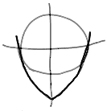
If you want your character to be facing in a direction other than straight forward, you're going to have to make other arrangements.
The basic method is the same...
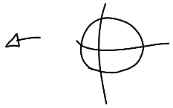
But certain facial proportions are going to be a bit different.
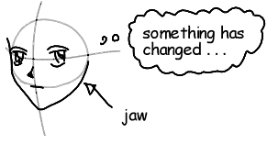
Here are some examples.
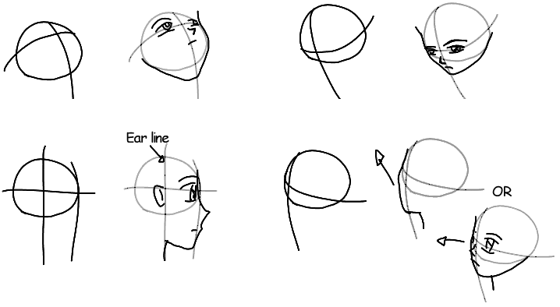

TIPS
- Make sure you remember where the hairline is. You don't want any abnormally flattened scalps. 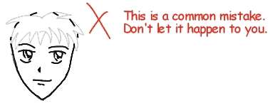
- Remember, this way is not the only way. Experiment. 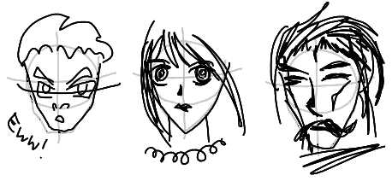
- When using foreshortening, remember to compress the eye. 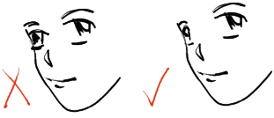
- When the head is tilted vertically, the proportions will squish together in different ways. This is tricky to pull off, but can make for an interesting effect. 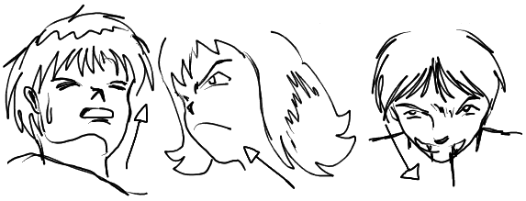
- The eyes are always above the cheekbone. Another common mistake. 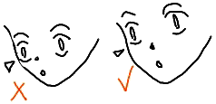
- Everything looks different in profile. Keep practicing. 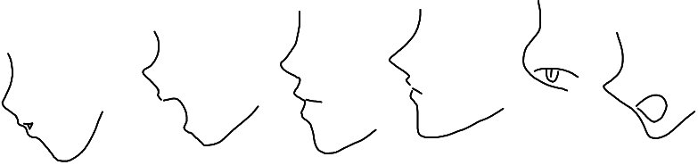
That's all there is from Animagess for now, but let her know what you think of her work, and perhaps we'll be seeing more lessons from her in the future.

